UI callback sequence for installation
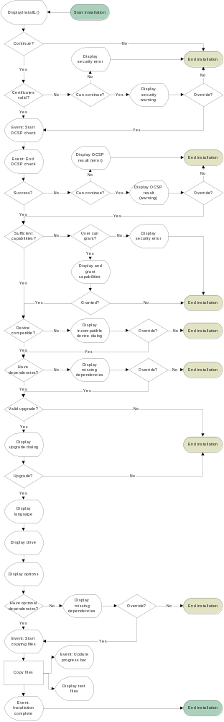

Events during the Execution Phase
Execute Installation (Copy files, etc.)
HandleCancellableInstallEventL(
EEventCopyingFiles
)
HandleInstallEventL(
EEventSetProgressBarFinalValue
)
HandleInstallEventL(
EEventUpdateProgressBar
)
HandleInstallEventL(
EEventCompletedInstall
)
User hits Cancel
HandleInstallEventL(
EEventAbortedInstall
)
User hits Cancel
User hits Cancel
HandleInstallEventL(
EEventCompletedUnInstall
)
HandleCancellableInstallEventL(
EEventShuttingDownApps
)
HandleCancellableInstallEventL(
EEventRemovingFiles
)
HandleInstallEventL(
EEventSetProgressBarFinalValue
)
HandleInstallEventL(
EEventUpdateProgressBar
)
HandleInstallEventL(
EEventAbortedInstall
)
User hits Cancel
If an error occurs
the appropriate
DisplayErroL() will
be called
If an error occurs
the appropriate
DisplayErroL() will
be called
DisplayUninstallL
Cancel

